NEWS RELEASE
For Immediate Release

Contact: Juliet Sinisterra, CEO, University District; Tel: (509) 255-8093, info@spokaneudistrict.org

UNIVERSITY DISTRICT APPOINTS NEW 2023 BOARD MEMBERS and board chair

SPOKANE, Wash., February 2, 2023—The University District Development Association (UDDA) is pleased to announce new board members for 2023 and welcome new board chair, Teresa Dugger. Board members serve two, three-year terms. For additional information about the UDDA board, including existing directors and officers, see this link.
Alicia Barbieri, Vice President, Goodale & Barbieri
Alicia Barbieri has been with Goodale & Barbieri Company since 2006 and is involved in the management, development, brokerage, and supervision of the Company's real estate portfolio. As a 5th generation Spokanite, Alicia is truly invested in the success of Spokane and surrounding areas. Alongside her grandfather, Lou Barbieri, and her father, Thomas Barbieri, Alicia has grown up in the real estate business. Alicia is a Gonzaga alum and serves on numerous regional boards including the Spokane Symphony.

Amber Waldref, Spokane County Commissioner, District 2
Newly elected Spokane County Commissioner, Amber Waldref, has deep experience in the non-profit sector, advocating for cleanup of the Hanford Nuclear Reservation, building partnerships at The Lands Council to support clean water and healthy forests, and developing the capacity of The ZoNE initiative at Northeast Community Center to remove barriers to economic opportunity for all children and families. During her eight years as a Spokane City Councilmember, Amber led efforts to clean up the Spokane River, improve streets and utilities, and support small business growth and public safety through targeted investment in the East Sprague District, the Hamilton Street Corridor, and in Downtown Spokane. Amber has a long history of volunteer and community service. She served on the Governor’s 2020 Census Counts Committee and currently serves on the Washington State University Spokane Advisory Council, the Holy Names Music Center Board of Trustees, the Hanford Advisory Board, and the Spokane County Human Rights Task Force.
Chuck Murphy, Chief Strategy Officer, Gonzaga University
Chuck Murphy is a Spokane native and alum of Gonzaga University. After four years in public accounting, he began his career at Gonzaga University in 1978 as Controller. He became Vice President for Finance in 1985 and served in that capacity until 2018 when he became the University’s Chief Strategy Officer. During his time at Gonzaga, he has had responsibility for all the financial affairs of the University, various operating areas of the University, as well as campus planning and construction. He currently serves on the boards of Catholic Charities and Catholic Housing Ventures. He also has a long history of Board and committee service at Gonzaga Prep. Chuck has served as the chair of the UDDA Development Committee and as the board proxy from Gonzaga University. Starting in 2023, Chuck will be an independent member of the UDDA Board and a member of the Executive Committee.

Colleen Fuchs, Executive Director, Joya Child and Family Development
Colleen has a longtime connection to Joya a non-profit providing early intervention services to infants and toddlers in Spokane County), formerly the Spokane Guilds’ School. In 2016 she was hired to serve as Joya’s program coordinator, overseeing a team of therapists and teachers and coordinating with Joya’s medical and social workers to deliver the best program possible for children and families. In 2019, Colleen was promoted to Executive Director and has led the 62-year-old organization through the construction of a new facility and move to the University District in 2022. Colleen has experience as a teacher and administrator in early childhood and elementary education; pediatric hospital and residential care of medically complex children; owning and operating a business; and in higher ed and early learning research. She is a Spokane native and has a bachelor’s degree in Education with endorsements in Elementary Education, Special Education, and Early Childhood Special Education from Gonzaga.

Dennis Wagner, VP of Retail Experience, Numerica Credit Union
Originally from Indiana, after graduating college from the University of Indianapolis with a degree in Business Management, Dennis moved to Spokane in 2006 after visiting his family and falling in love with the area and community. He has been with Numerica Credit Union since 2016. Before working for Numerica, Dennis was with Chase Bank for eight years, and CitiFinancial for seven years. Dennis has had the privilege of being a leader/influencer for the past 22 years in different managerial capacities. Nothing excites him more than seeing the impact – no matter how small – he’s had on those around him. Dennis’ passion is making others better, not just professionally, but personally as well.

Emilie Cameron, President and CEO, Downtown Spokane Partnership
An experienced urban place management executive, Emilie works closely with property and business owners, stakeholders, elected officials, and the community to build and grow programs spanning economic development, business support, urban planning, investment and tourism marketing, transportation, security, and maintenance. Emilie is a passionate advocate for a strong downtown that can fuel a prosperous Spokane region. A recent transplant to the Inland Northwest, Emilie’s prior experience includes leading catalytic downtown projects at the intersection of policy and politics in California’s capital city. She successfully participated in the International Downtown Association’s Emerging Leadership Fellowship in 2018 and more recently served as 1st Vice Chair of the California Downtown Association (CDA) Board of Directors where she led statewide advocacy on behalf of downtowns and urban centers across the Golden State. Emilie is an alumna of the University of California, Davis earning her B.A. in History.

Erin Williams Hueter, Executive Director, Health Sciences and Services Authority (HSSA)

Williams Hueter has been working in human services and violence prevention since the mid-1990s and has been involved in the innovative training recovery work at Lutheran Community Services Northwest, most recently as its director. She has a Bachelor of Arts degree from Pacific University, with a major in Social Work. She is a graduate of the Leadership Spokane program and has received many honors for her achievements in her field.

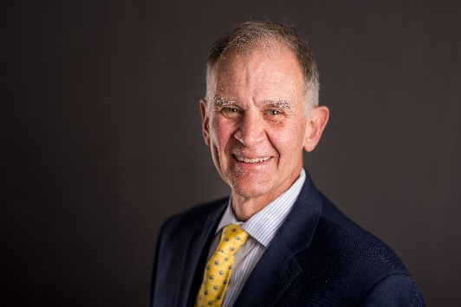
Greg Repetti, President, MultiCare INW Hospitals and Regional Strategic Implementation

Gregory Repetti is a seasoned healthcare executive with 40 years of experience. He is a 1980 graduate of Yale University where he majored in Biology. He received his Master’s in Health Services Administration in 1982 from The Ohio State University. Greg has held key leadership roles at several organizations including the Medical College of Philadelphia and Paoli Memorial Hospital, Silver Cross Hospital, and Vail Valley Medical Center. He came to Spokane in 2010. He served as Chief Operating Officer of Deaconess Hospital for almost three years before being hired as COO at Rockwood Clinic in 2013. He then served as President of Valley Hospital in Spokane Valley and in May 2020, Greg became the President of the MultiCare Inland Northwest Hospitals (which includes both Deaconess and Valley Hospitals). In March 2022, Greg also assumed the Regional Strategic Implementation role. He has been a faculty member of the American College of Healthcare Executives. He also serves on many community Boards including the Past Chairman of the Greater Spokane Valley Chamber of Commerce.

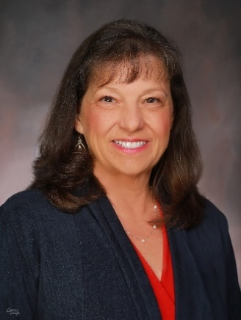
Susan Stacey, President, Providence Spokane and Stevens Counties

Susan began her healthcare career with Providence more than 35 years ago, starting as a bedside nurse in the pediatric intensive care unit. She has held many leadership roles in the last 15 years, including nurse manager, director, and executive director of the children’s hospital and women’s services. In 2013, Susan served as the chief nursing officer for Providence Sacred Heart Medical Center and Children’s Hospital and in 2018 she expanded her role to include the chief operating officer of and the regional chief nursing officer representing all hospitals and clinics in Washington and Montana. Susan is active in the community and state through her involvement on several boards, including Washington State University Healthcare Advisory, Northwest Organization of Nurse Leaders, and Washington State Hospital Association. She has been a consistent advocate for health-related issues at the legislative level, as well as a speaker on important hospital issues. Susan holds a Bachelor of Science in Nursing from Washington State University and a Master of Business Administration in healthcare leadership from the University of Phoenix. She is a fellow in the American College of Healthcare Executives and holds several certifications as a nurse and hospital leader.

Teresa Dugger, Associate Technical Engineer, GeoEngineers – 2023 UDDA/UDPDA Board Chair

Teresa has served on the UDDA board since 2019 and has been an active member of the Development Committee and other advisory committees. At GeoEngineers, Teresa oversees the development of geotechnical engineering evaluations—from proposal to final report—and is a main client/owner contact for her projects. Teresa’s technical experience is broad, including experience managing large geotechnical evaluations for regional energy providers, natural resource work transportation authorities, design-build projects, and construction monitoring. Her leadership role has grown within the Spokane geotechnical team over the past 20+ years. She’s the geotechnical team leader for our West business unit, based in Spokane, and she manages a number of important client relationships. Teresa is also deeply involved in the Spokane business community and actively promotes new business opportunities where available.

###

The University District offers opportunities to address economic development issues, smart urban growth, environmental restoration, transportation improvements, and housing needs. Connecting the core strengths of the educational institutions with regional economic drivers, the University District provides an urban laboratory for the creation of new knowledge and opportunities for community-engaged research that builds economic value and quality of life. Find out more at www.spokaneudistrict.org.

